姓名 | 学号 | 联系电话 | 邮箱
葛佳亮 | 5030309597 | 13795484760 | ge_jia_liang@hotmail.com


Contents
1. General Introduction 1
1.1 Values and Purposes 1
1.2 Overall Architecture 1
2. WebSearch.DataCenter.Net 2
2.1 Data Source 2
2.2 Data Access Interfaces 3
2.3 Facets of Data Center 4
3. WebSearch.Feature.Net 5
3.1 Linguistic Feature 5
3.2 Click-Through Feature 5
3.3 User Query Feature 6
3.4 Other Features 6
4. WebSearch.DataMiner.Net 7
4.1 Decision Tree 7
5. WebSearch.Model.Net 8
5.1 Overview 8
6. WebSearch.Linguistics.Net 9
7. WebSearch.Crawler.Net 10
7.1 WebCrawler 10
7.2 WebProxies 11
8. WebSearch.Maths.Net 12
9. WebSearch.Common.Net 13
10. Other Open-source Refs. 16
10.1 SharpNLP 16
10.2 Lucene.Net 16
10.3 ICTCLAS 17
11. WebSearch.Net Demos 18
12. WebSearch.Net Installer 19

General Introduction

Values and Purposes
WebSearch.Net is an open-source research platform that provides uniform data source access, data modeling, feature calculation, data mining, etc. It facilitates the experiments of web search researchers due to its high flexibility and extensibility. The platform can be used or extended by any language compatible for .Net 2 framework, from C# (recommended), VB.Net to C++ and Java. Thanks to the large coverage of knowledge in web search research, it is necessary to model the techniques and maintain them in a solution. WebSearch.Net platform will grow robust when more and more people are involved in this work.

Overall Architecture
The current solution comprises DataCenter.Net (provides a uniform access to data source), Model.Net (provides modeling for the entities in web search), Feature.Net (provides the feature calculation), DataMiner.Net (a data mining library) and other utilities like Linguistics.Net (an adapter for SharpNLP, NICTCLAS and etc.), Common.Net (the common utilities for all module in the solutions). In the mean time, the WebSearch.Net references several open-source projects from SourceForge and CodePlex: Lucene.Net 1.9 is a well-known indexer; SharpNLP and NICTCLAS tokenizes and POS the English or Chinese characters. The system architecture may changes with time and more and more web search techniques will be added in future.

The following diagram shows the project dependencies in the solution.

WebSearch.DataCenter.Net

Data Source
The current supported data source types for research include query log, web collection, link collection, query collection and corpus. The supported store types include the file system (using Lucene.Net as indexer), data base (using Microsoft SQL server 2005 FTS as indexer) and internet (using search engines as indexer). The data source type and store type are extensible. Researchers may add their own data source type or store type by following several rules.
1. Data Source Type
All data source types are defined in the namespace: WebSearch.DataCenter.Net.DS. They are derived from class WebSearch.DataCenter.Net.DS.DataSource. The following shows the class diagram.
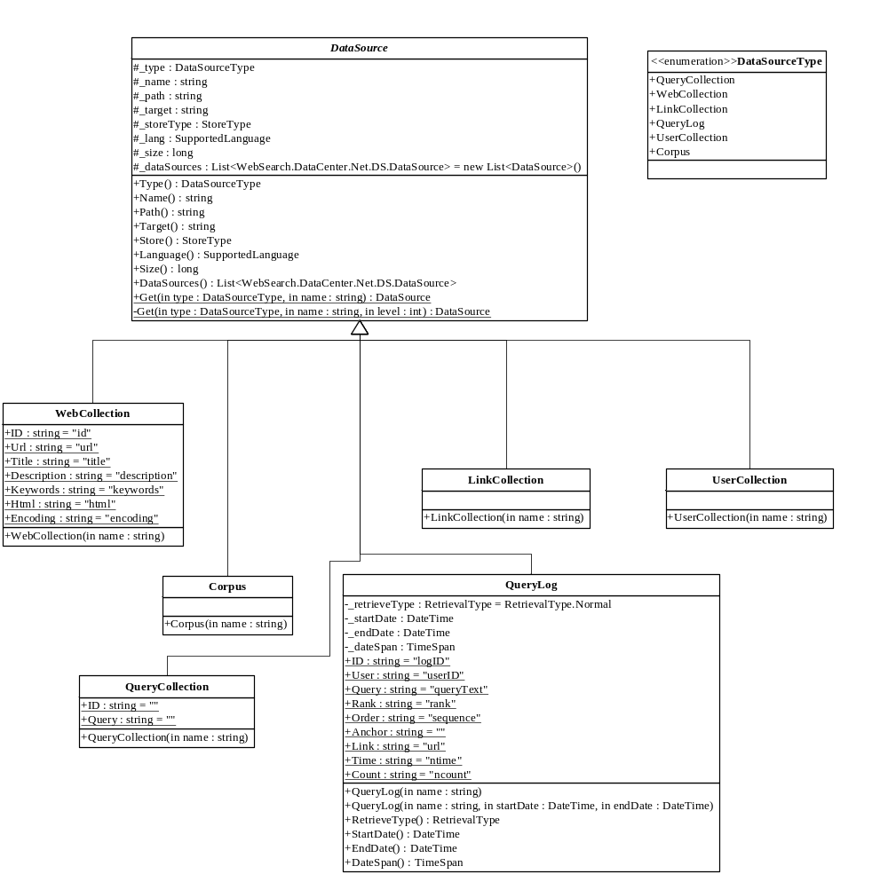
For each data source type, it should be registered in enumeration type: DataSourceType and has a derived-class in which the structure of the data source should be defined. Besides, each data source type has an xml file where the corresponding data sources are configured according to pre-defined DTD. For instance, Sogou query log is configured in QueryLog.xml as [Table-2.1.1] according to the query log data source DTD in [table-2.1.2]
<QueryLog _Name="Sogou" _StartDate="2006-08-1" _EndDate="2006-09-01"
_Path="Data Source=192.168.3.25;Initial Catalog=SogouQ;User ID=sa;Password=111111"
_Target="[accesslog_200608]" _Store="MSSQL" _Language="Chinese" _Size="1000000" />
[Table-2.1.1]
<?xml version="1.0" encoding="utf-8" ?>
<!DOCTYPE root [ <!ELEMENT root ANY>
<!ELEMENT QueryLog ANY>
<!ATTLIST QueryLog _Name ID #REQUIRED>
<!ATTLIST QueryLog _Path CDATA #REQUIRED>
<!ATTLIST QueryLog _Target CDATA #REQUIRED>
<!ATTLIST QueryLog _Store CDATA #REQUIRED>
<!ATTLIST QueryLog _Language CDATA #REQUIRED>
<!ATTLIST QueryLog _Size CDATA "0">
<!ATTLIST QueryLog _StartDate CDATA #REQUIRED>
<!ATTLIST QueryLog _EndDate CDATA #REQUIRED>
<!ELEMENT DataSource ANY>
<!ATTLIST DataSource _SubType CDATA #REQUIRED>
<!ATTLIST DataSource _SubName CDATA #REQUIRED>
]>
[Table-2.1.2]
Researchers may add their own query logs by adding such a query log xml node.
To get a data source, you may call the method ‘Get’ in DataSource base class.
public static DataSource Get(DataSourceType type, string name)
For instance:
QueryLog queryLog = (QueryLog)DataSource.Get(DataSourceType.QueryLog, "Sogou");

2. Store Type
The supported storage types are file-system (using Lucene.Net as indexer), data base (using Microsoft SQL Server FTS as indexer) and internet (using search engines like Google, Sogou, Baidu as indexer).
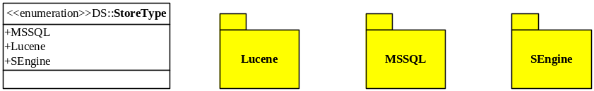
Actually, different store type determines different implementation of data access methods. Researchers may feel free to add other store type like Oracle data base.

Data Access Interfaces
Each data source type corresponds to a data access interface in which the access methods are declared. These interfaces may have different implementations for different storage types. For instance, the current query log interface: IQueryLog is realized in Lucene.Net and MSSQL. That is to say, query logs stored in data base and file system are supported.

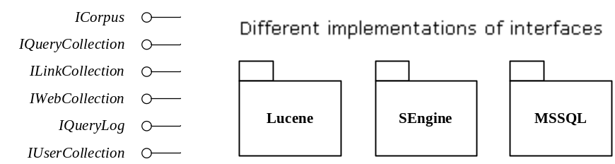
In the configuration of data sources, researchers should specify the storage type so that the platform is able to instantiate the interface correctly.

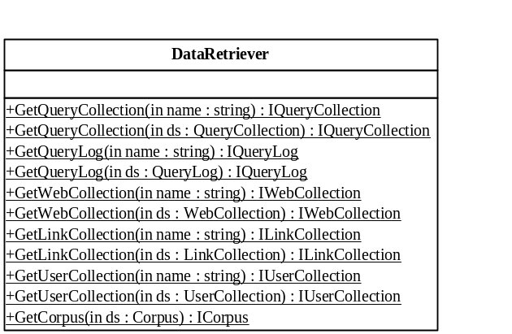Facets of Data Center

The class DataRetriever is the facet class for data retrieval. It helps to get the data access object according to the specified data source. Then researchers may call the data access methods defined in the data access object to retrieve data.

The class DataBuilder maintains the interfaces for building or creating data sources. The following class diagram depicts part of methods exposed. Researchers may import data to create a data source or create a new one from other existing data sources.
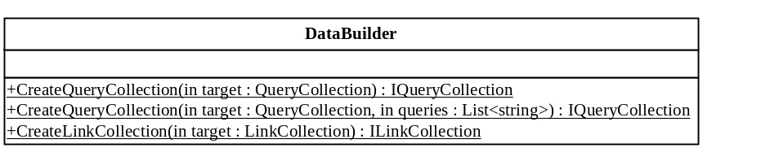

WebSearch.Feature.Net
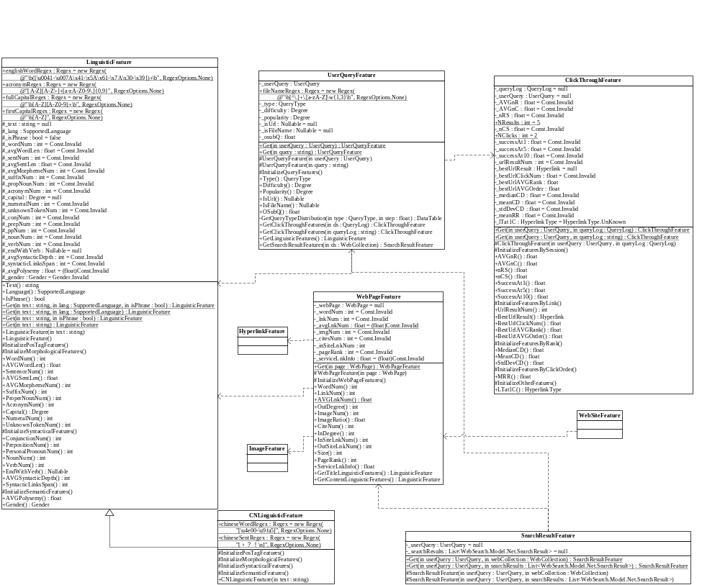

Linguistic Feature
Linguistic features are composed of morphological, syntactical and semantic features. First, morphological features are relating to or concerned with the formation of admissible words in a language, such as average word length in a sentence, word number, acronym number, etc. Syntactical features, on the other hand, are relating to or conforming to the rules of syntax, like conjunction number, personal pronoun number, average syntactic depth and so on. Finally, semantic features are relating to meaning or the study of meaning. For example, the average polysemy is a typical semantic feature.

The class, LinguisticFeature, is for analyzing English words or sentences. CNLinguisticFeature, a derived class from LinguisticFeature, is for Chinese feature calculation. Both of them reference the project WebSearch.Linguistics.Net for some POS and tokenization helpers.

Click-Through Feature
Click-through features are extracted from query log. They are based on the query log data that is retrieved grouped by session, link, rank, and user click order. For instance, average click number per session for the query, or AVGnC, accounts how many results a user clicks on after the query is issued.

The class ClickThroughFeature is the place where all the click-through features are figured out. You may also read the document: Features in Web Search.doc to get a clearer view of the features.

User Query Feature
Most users interact with search engines with short queries composed of 4 or even fewer words. Such short phrases prevent the search engines from finding users’ information need behind the query, therefore, the feature extraction from user query turns more and more important in personalization, query type identification, query difficulty evaluation and so on.

The main user query features are query type, query difficulty, query similarity, query support, query popularity and queries’ linguistic and click-through features. Thus, User Query Feature is dependent on Linguistic Feature and Click-Through Feature.

Other Features
More detailed descriptions about hyperlink feature, search result feature, web image feature, web page feature, web site feature are documented in Features in Web Search.doc.

WebSearch.DataMiner.Net
(Unfinished)

Decision Tree
ID3 Decision Tree is supported.

WebSearch.Model.Net
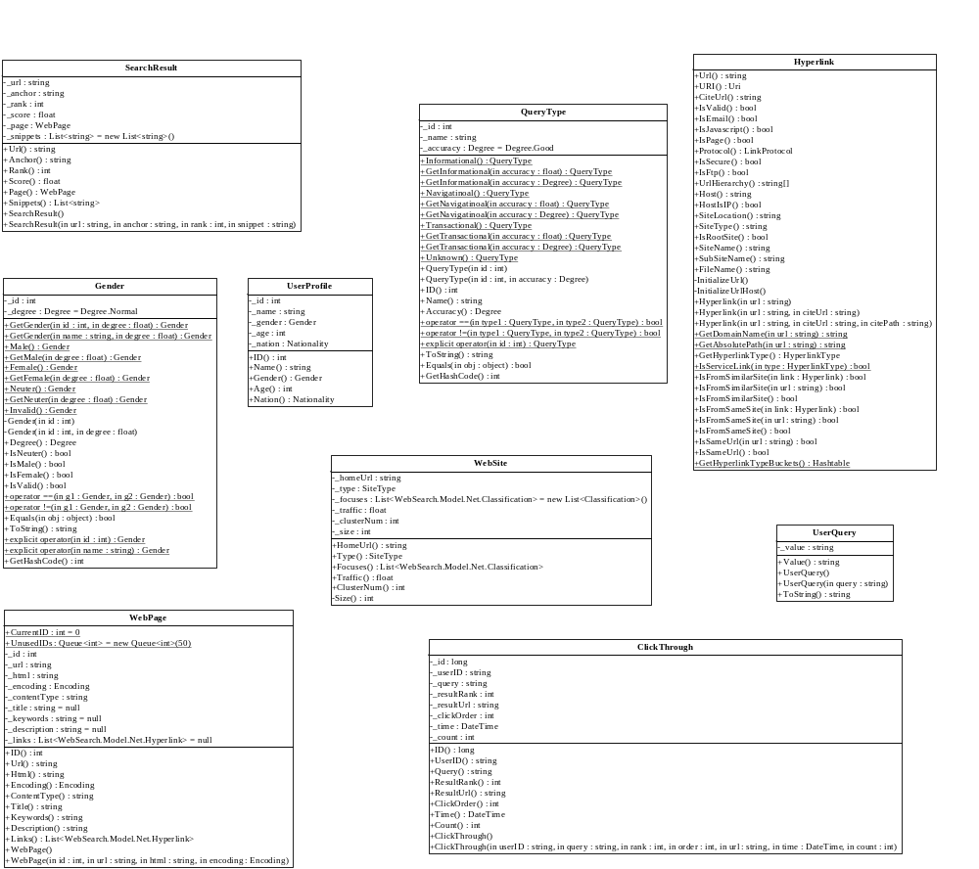

Overview
Model.Net modelizes the entities, such as web page, user query, in web search. Each model has its own properties or attributes and there could be association/integration relations between models. Model.Net is extensible. Researchers could add or extend their own models according to specific problems. For instance, a researcher experimenting on web blog pages may extend a model named ‘WebBlogPage’ from ‘WebPage’ and add blog-specific attributes into ‘WebBlogPage’.

Please note the difference between the model properties and model’s corresponding features (see Feature.Net): Model’s property or attribute is the raw data that do not involve calculations. They can be directly achieved from data sources. Yet, the features are in need of complex calculations and estimations.

WebSearch.Linguistics.Net
The current WebSearch.Linguisitcis.Net project is actually an adapter or wrapper for other open-source linguistic projects like SharpNLP, NICTCLAS, etc now. It provides a uniform access to linguistic analysis, including tokenization, POS, Synset detection, gender estimation, and so on.

WebSearch.Crawler.Net
WebSearch.Crawler.Net is a utility to build a web crawler. It supports both the single-threaded and multi-threaded crawling. Researchers can either specify a list of URLs for it to crawl or give a seed site URL and the crawler will spider the network to retrieve the web page. The options include ‘Allow Leave the Seed Site?’, ‘Crawling Depth?’, ‘Download Image?’, ‘Timer Interval?’ and so on. You may even configure the network proxy when you local network is limited.

WebCrawler
The class WebCrawler’s class diagram:
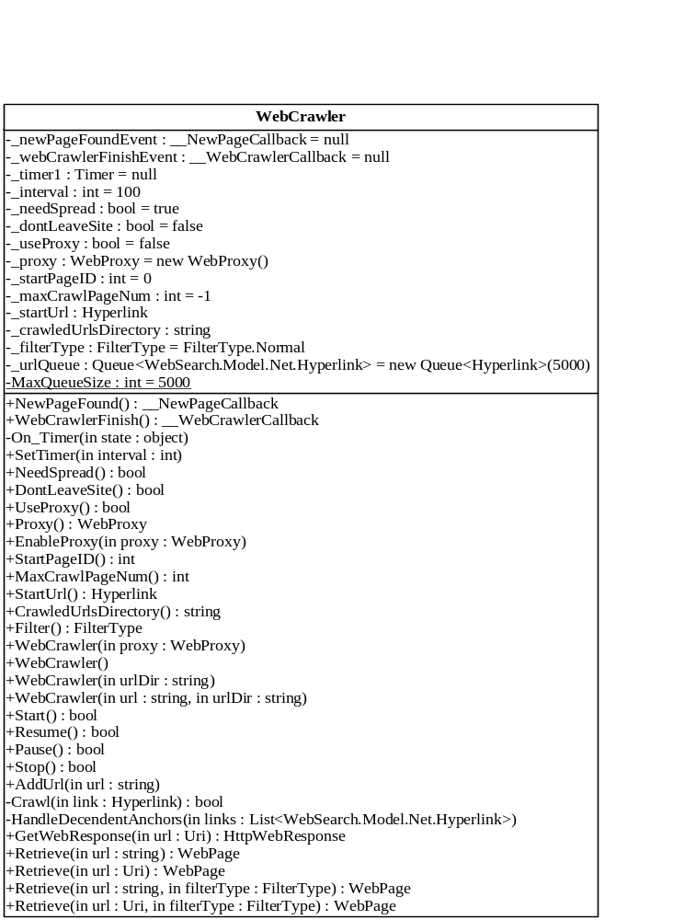

Single-threaded mode:
When the crawler is running under single-threaded mode, you may iteratively call the Retrieve method in WebCrawler and get a WebPage object as result. The current version of Single-threaded mode does not support asynchronous call.

Multi-threaded mode:
Under multi-threaded mode, the crawler uses a System.Threading.Timer object to trigger the crawling event periodically. In every period, the crawler will create a new thread to crawl a page. The interval of the timer can be set in method: SetInterval. The whole process is in asynchronous invoke. That is to say, after the method ‘Start’ and is called, the client needs a callback function to accept the result web page.

WebProxies
The class WebProxies helps to create a System.Net.WebProxy object according to the specified proxy name. All web proxies are configured in xml file: proxies.xml.

WebSearch.Maths.Net
WebSearch.Maths.Net provides a mathematics library where statistic utilities, probability utilities are included.

WebSearch.Common.Net
WebSearch.Common.Net provides the common utilities and setting throughout the solution.
The utilities include:
- XmlHelper: an easier helper for access (read/write) xml files
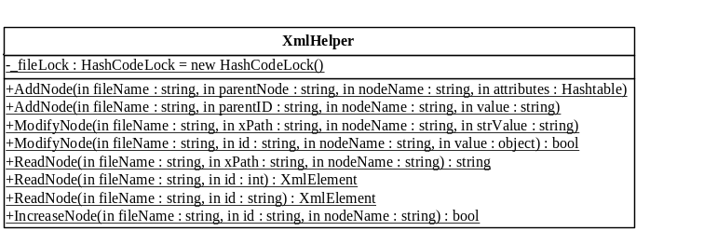
- HtmlParser: a parser for html tags. It can filter or find specified tags in an html.
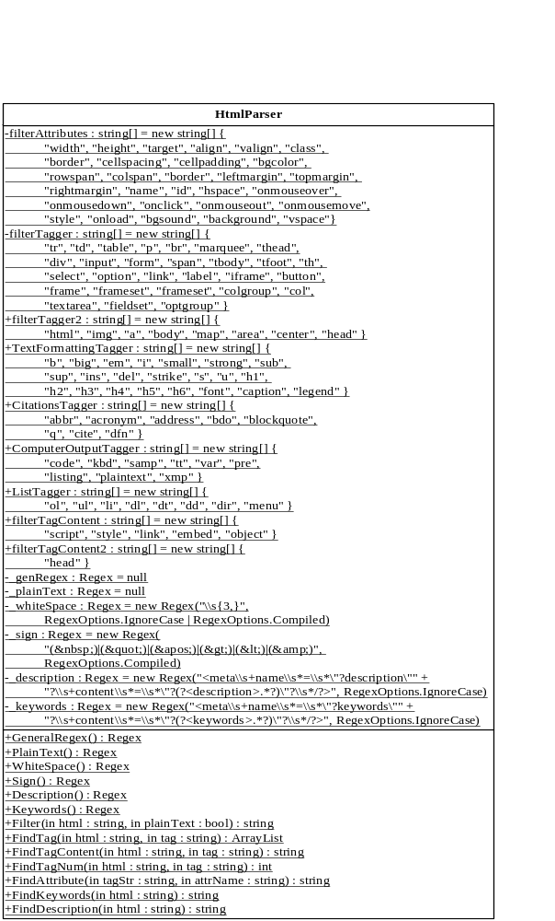
- EnumHelper: a helper for enum type operations like enum, integer and string inter-conversion.
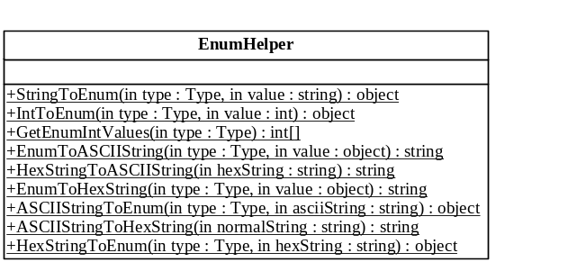
- EncodingHelper: a utility that can detect the encoding of a file, a page or an array of charaters.
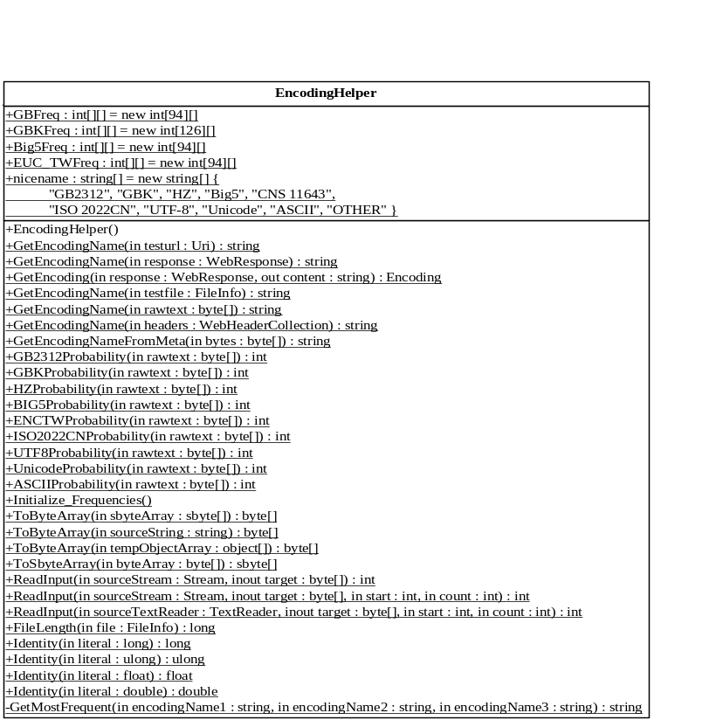
- EmailHelper/EmailAlerter: a email helper that can send emails or alerts according to configs.
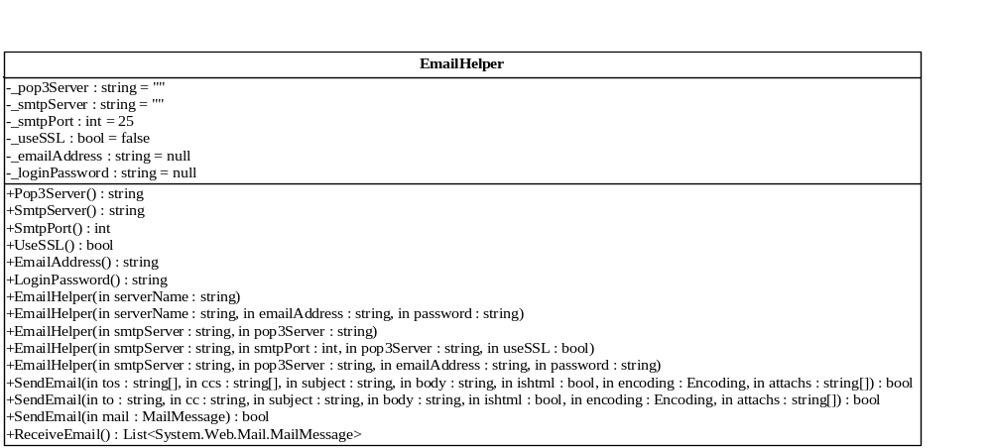
- IWin32: some PInvokes of Win32 API from .NET framework.
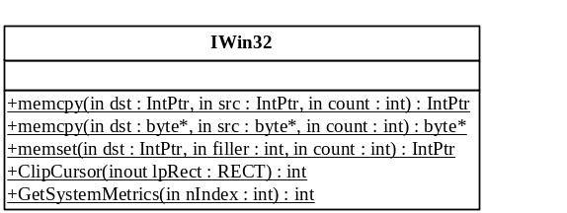
- Const: constants used throughout the solution.
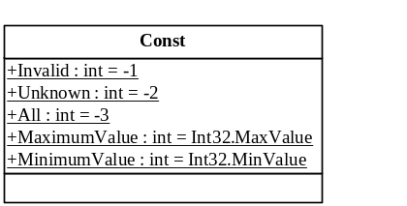

Other Open-source Refs.

SharpNLP
SharpNLP is a collection of natural language processing tools written in C#. It is both the name of a group of open source projects (http://opennlp.sourceforge.net) related to natural language processing (NLP), and the name of a library of NLP tools written in Java by Jason Baldridge (http://sourceforge.net/projects/opennlp), Tom Morton, and Gann Bierner. SharpNLP is a C# port of the Java OpenNLP tools, plus additional code to facilitate natural language processing. All of these tools are driven by maximum entropy models processed by the SharpEntropy library. In addition, SharpNLP contains a WordNet database access library called SharpWordNet.

Currently it provides the following NLP tools:
- a sentence splitter
- a tokenizer
- a part-of-speech tagger
- a chunker (used to "find non-recursive syntactic annotations such as noun phrase chunks")
- a parser
- a name finder
- a coreference tool
- an interface to the WordNet lexical database

Lucene.Net
Lucene.Net is a source code, class-per-class, API-per-API and algorithmatic port of the Java Lucene search engine to the C# and .NET platform utilizing Microsoft .NET Framework.

Lucene.Net is an effort undergoing incubation at the Apache Software Foundation (ASF). Incubation is required of all newly accepted projects until a further review indicates that the infrastructure, communications, and decision making process have stabilized in a manner consistent with other successful ASF projects. While incubation status is not necessarily a reflection of the completeness or stability of the code, it does indicate that the project has yet to be fully endorsed by the ASF.

The incubation status is recorded at http://incubator.apache.org/projects/lucene.net.html

Lucene.Net sticks to the APIs and classes used in the original Java implementation of Lucene. The API names as well as class names are preserved with the intention of giving Lucene.Net the look and feel of the C# language and the .NET Framework. For example, the method Hits.length() in the Java implementation now reads Hits.Length() in the C# port.

In addition to the APIs and classes port to C#, the algorithm of Java Lucene is ported to C# Lucene. This means an index created with Java Lucene is back-and-forth compatible with the C# Lucene; both at reading, writing and updating. In fact a Lucene index can be concurrently searched and updated using Java Lucene and C# Lucene processes.

ICTCLAS
ICTCLAS is an open-source project from Inst. of Computing Tech., CAS in the ACL SIGHAN-sponsored First International Chinese Word Segmentation Bake-off. The authors introduce the unified HHMM-based frame of the Chinese lexical analyzer ICTCLAS and explain the operation of the six tracks. Then provide the evaluation results and give more analysis. Evaluation on ICTCLAS shows that its performance is competitive. Compared with other system, ICTCLAS has ranked top both in CTB and PK closed track. In PK open track, it ranks second position.

WebSearch.Net Demos

WebSearch.Net Installer
This setup project will install the whole WebSearch.Net platform and demos into the local hard disk and add the assemblies into .NET GAC so that applications can easily reference the libraries. In the mean time, the platform uses Click-Once technique, thus it will be updated in time when new release is available.

